Assessment 2
Tristan Sim Yook Min (30428831)

Question 1: Bayesian Networks, Netica
1.a: Add the necessary nodes and edges to your BN,and input the corresponding conditional probability tables. Justify your expanded network and CPTs.

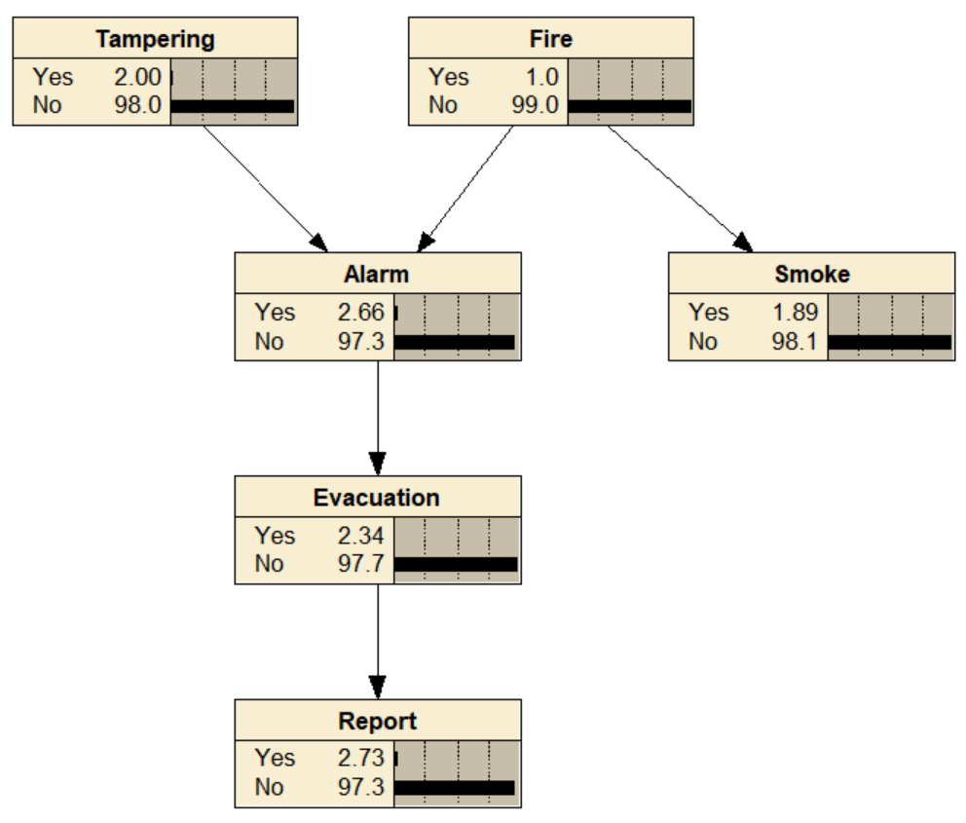

The table below shows the justification for the expanded networks:
Item | Type | Justification
Smoke | Chance Node | Represents the presence of Smoke in the building
Evacuation | Chance Node | Represents the chance of an Evacuation
Report | Chance Node | Represents the chance a newspaper coverage is made
Fire to Smoke | Conditioning Link | Fire causes the smoke to be visible
Alarm to Evacuation | Conditioning Link | The alarm alerts occupants to evacuate the building
Evacuation to Report | Conditioning Link | News Media will report emergency events

Question 1: Bayesian Networks, Netica

The table below shows the justification for the Conditional Probabilities Tables:
Conditional Probability Table for Smoke Node
Fire | Yes | No | Justification
Yes | 90 | 10 | When there is a fire, there is a 90% likelihood of smoke occurring
No | 1 | 99 | There is only 1% chance of smoke when there is no Fire, could be a false positive result of someone cooking

Conditional Probability Table for Evacuation Node
Alarm | Yes | No | Justification
Yes | 88 | 12 | When there is an Alarm, there is an 88% chance of Evacuation as this is a natural response to hearing an alarm
No | 0 | 100 | The is Never an Evacuation if there is No Alarm because there or no other events that will result in an evacuation

Conditional Probability Table for Report Node
Evacuation | Yes | No | Justification
Yes | 75 | 25 | There is a 75% chance the Evacuation will make a news report whilst there a fair chance it may go unreported
No | 1 | 99 | 1% chance a news report is made when there is No Evacuation since there usually nothing eventful to report

Justification:

The Expanded Bayesian Network is implemented in Netica and is shown in the diagram in the previous page. The additional chance nodes were added into the directed acyclic graph structure to represent the emergency response to a fire.

The Smoke Node has a conditioning link to Fire. This is a causal chain relationship as the presence of smoke is the direct result of fire. However, the Fire Node now has two child nodes, making it a Common Cause for both Alarm and Fire. The occurrence of fire will directly affect both an alarm triggering and smoke to be present.

The Evacuation Node is a child of Alarm, creating a causal chain relationship. When the alarm triggers, a building evacuation will most likely happen. The Report Node is a child of Evacuation, continuing the causal chain where the occurrence of evacuations generates news reports.

Question 1: Bayesian Networks, Netica
s
1.b. Use Netica on the expanded BN to answer the following questions:

Question Number | Question | Answer
1.b.i | Pr(Tampering=T) | 2.00%
1.b.ii | Pr(Report=T) | 2.73 %
1.b.iii | Pr(Report=T | Smoke=T) | 32.0 %
1.b.iv | Pr(Tampering=T | Report=T, Fire=F) | 53.5 %
1.b.v | Pr(Tampering=T | Smoke=F) =?  Conditional independence property? | 2.00 %  Tampering and Smoke are conditionally independent given smoke. Since Alarm is a Common Effect of Tampering and Fire, and is Not Observed, this blocks information flow and d-separates Tampering from Smoke. Therefore, observing the absence of smoke provides no information about tampering, leaving the probability unchanged.
1.b.vi | Pr(Tampering=T | Report=T, Smoke=F)  Explain | 51.9 %  Since there was a News Report (causal chain with evacuation and alarm) but no smoke was observed, the News Report being a descendant node of Evacuation and Alarm, unblocks the path at the Common Effect Alarm. Since no smoke was observed, Fire has a much lower probability of occurring and Tampering becomes the likely cause for the alarm triggering. This demonstrates the "explaining away" concept whereby ruling out Fire as a cause increases the likelihood that tampering is the cause of the alarm.
1.b.vii | Pr(Tampering=T | Fire=F, Report=T, Smoke=T)  Write the independence property (D-separation)  Describe your answer | 53.5 %  Tampering ⊥ Smoke | Fire  Tampering and Smoke are conditionally independent and d-separated given Fire. Observing the presence of smoke does not affect the posterior probability of Tampering (remains 53.5%). Fire is the common cause for alarm and smoke, and when observed as "No Fire", blocks the flow of information between them. This evidence strongly suggests that the smoke detector was most likely tampered with.

Question 1: Bayesian Networks, Netica

1.c. Briefly justify your answers by indicating whether the variables in question are connected or D-separated, and which variable(s) block or unblock the path — use the terms of Common Cause, Common Effect and Causal Chain where applicable.
* True: independent; False: connected.
Statement | Tampering ⊥ Evacuation
True/False | False
Rule Applies | 1) Causal Chain (Tampering → Alarm → Evacuation)
Explanation | This is a Causal Chain where information can freely flow and is not blocked through the chain. Tampering and Evacuation are connected and dependent as information flows freely through the Alarm Node.

Statement | Tampering ⊥ Evacuation | Alarm
True/False | True
Rule Applies | 1) Causal Chain (Tampering → Alarm → Evacuation)
Explanation | Alarm Node is now observed; this Causal Chain is now blocked. Information cannot flow through from Tampering to Evacuation. Hence, it is conditionally independent and d-separated by Alarm.

Statement | Tampering ⊥ Evacuation | Smoke
True/False | False
Rule Applies | 1) Common Cause (Alarm ← Fire → Smoke)  2) Causal Chain (Tampering → Alarm → Evacuation)
Explanation | When Smoke is observed, it provides evidence for Fire which is a Common Cause for Both Alarm and Smoke. But this does not affect the information flow between Tampering and Evacuation because of the existing Causal Chain linking them. Therefore, they remain connected and dependent given Smoke.

Statement | Tampering ⊥ Fire
True/False | True
Rule Applies | 1) Common Effect (Tampering → Alarm ← Fire)
Explanation | This path is a Common Effect and when Alarm is Not Observed, the v-structure Blocks between Tampering and Fire Node, making Tampering and Fire independent and d-separated.

Question 1: Bayesian Networks, Netica

Statement | Tampering ⊥ Fire | Alarm
True/False | False
Rule Applies | 1) Common Effect (Tampering → Alarm ← Fire)
Explanation | This path is a Common Effect and since Alarm is Now Observed, the path is now Unblocked and information can flow between Tampering and Fire Node, making them conditionally dependent given Alarm.

Statement | Alarm ⊥ Smoke
True/False | False
Rule Applies | 1) Common Cause (Smoke ← Fire → Alarm)
Explanation | Fire is a Common Cause for Alarm and Smoke and since Fire is Not Observed, the information flow is not blocked. Therefore, Alarm and Smoke are connected and dependent as information can freely flow.

Statement | Smoke ⊥ Report
True/False | False
Rule Applies | 1) Common Cause (Smoke ← Fire → Alarm)  2) Causal Chain (Alarm → Evacuation → Report)
Explanation | The path between Smoke and Report goes through a Common Cause and then followed by a Causal Chain.  Since No Nodes are observed along this path, the information is not blocked and can flow freely through them. Smoke and Report are connected and dependent because the common cause and Causal chain paths are bridging the information together.

Statement | Smoke ⊥ Tampering
True/False | True
Rule Applies | 1) Common Cause (Alarm ← Fire → Smoke)  2) Common Effect (Tampering → Alarm ← Fire)
Explanation | The Alarm Node is a Common Effect of Tampering and Fire. Since Alarm Node is Not Observed, this blocks information flow between the Tampering and Smoke. Although Fire is a Common Cause for alarm and smoke, means information is not blocked between them since Fire is not observed. This means Tampering and Smoke independent and d-separated from each other.

Question 1: Bayesian Networks, Netica

Statement | Smoke ⊥ Tampering | Alarm
True/False | False
Rule Applies | 1) Common Cause (Alarm ← Fire → Smoke)  2) Common Effect (Tampering → Alarm ← Fire)
Explanation | The Fire Node is a Common Cause for both Alarm and Smoke Node and when unobserved, information is not blocked and allowed to freely flow between its child nodes.  The Alarm Node is a Common Effect and has two causes which are Tampering and Fire. The Alarm Node when observed, unblocks the path at the collider and allows information to flow between the Tampering and Smoke Node, making them conditionally dependent.

Statement | Smoke ⊥ Tampering | Report
True/False | False
Rule Applies | 1) Common Cause (Alarm ← Fire → Smoke)  2) Common Effect (Tampering → Alarm ← Fire)  3) Causal Chain (Tampering → Alarm → Evacuation → Report)
Explanation | Fire is a Common Cause for both Alarm and Smoke and since it is not observed, the information is not blocked and can flow between Smoke and Alarm.  When Report is observed, it provides evidence to Evacuation, which in turn provides evidence to Alarm through the causal chain. These descendant nodes provide partial evidence to Alarm enough to unblock the flow of information at this Common Effect.  Hence, information can flow between Smoke and Tampering making them conditionally dependent given Report.

Question 1: Bayesian Networks, Netica

1.d. Based on your BN, construct a Bayesian Decision Network (BDN) that decides whether the building should be evacuated. That is, instead of having an Evacuation chance node, you should have a decision node that determines whether you should evacuate the building. Specify and justify the information links and the values in the utility node.

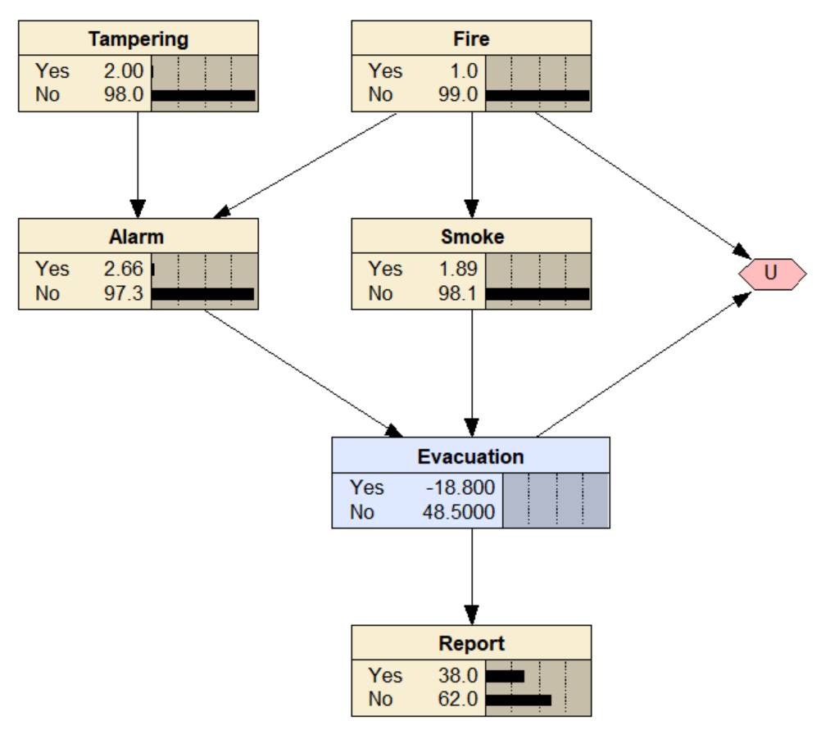

The Evacuation node has been changed to a decision node to determine if occupants should evacuate the building. The evacuation node receives information from both alarm and smoke, as occupants react to the fire alarm and observe the presence of smoke to directly infer the likelihood of an actual fire. Unlike smoke and alarm, fire and tampering may not be immediately known. The Utility Node depends on fire which is the actual danger and the evacuation which is the decision taken in response to said danger. The utility score depends on the positive/negative relationship between the outcome and actions. The Utility Node information is tabulated below.

Chance Node | Evacuation | Utility | Justification
Fire = Yes | Yes | 100 | Maximum Utility as Residents Must Evacuate during a Fire
Fire = Yes | No | -100 | Worse Possible Utility occupants did not Evacuate and Danger
Fire = No | Yes | -20 | Fairly Poor Utility as there was a False Alarm Triggered
Fire = No | No | 50 | Normal Utility as No Fire means No Alarm is Triggered

Question 1: Bayesian Networks, Netica

For example, with no alarm or smoke, the default decision to evacuate is “No” with an expected utility of 48.5%. When the Alarm is triggered, but the presence of Smoke is still not known to the occupants, the decision nodes will most likely choose to Evacuate with a Utility of 24.17% for “Yes” as shown below.

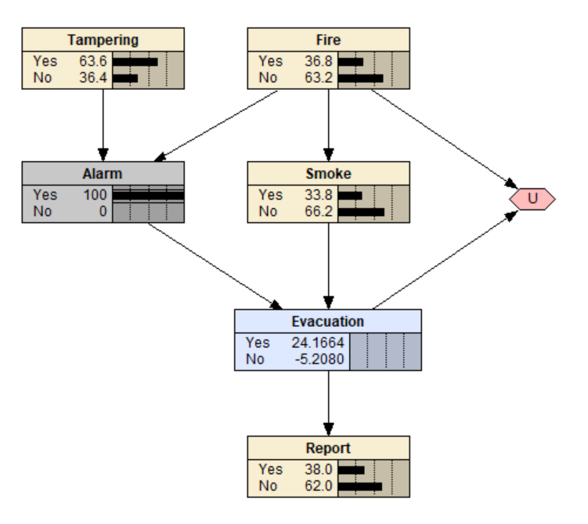
From the Diagrams below, if the occupants hear the alarm but observe no smoke, the decision to evacuate is still “No” with an expected utility of 41.67% due to a possibility of a false alarm. However, when there is smoke and the alarm has been triggered, the decision to evacuate is “Yes” with an expected utility of 97.75%, maximizing the utility to evacuate due to the likeness of an actual fire.

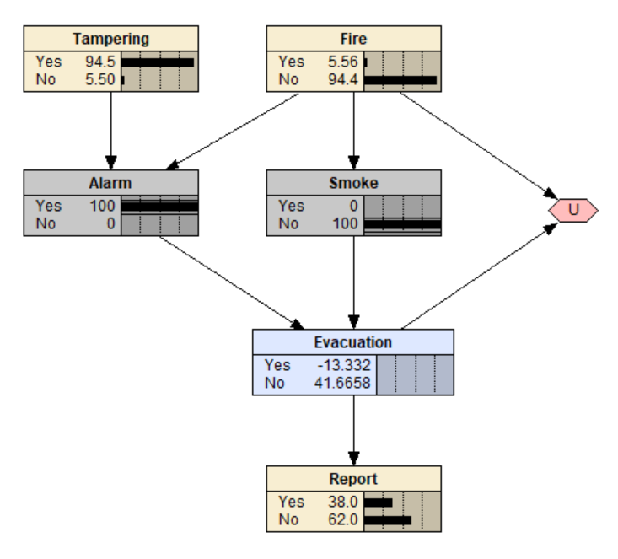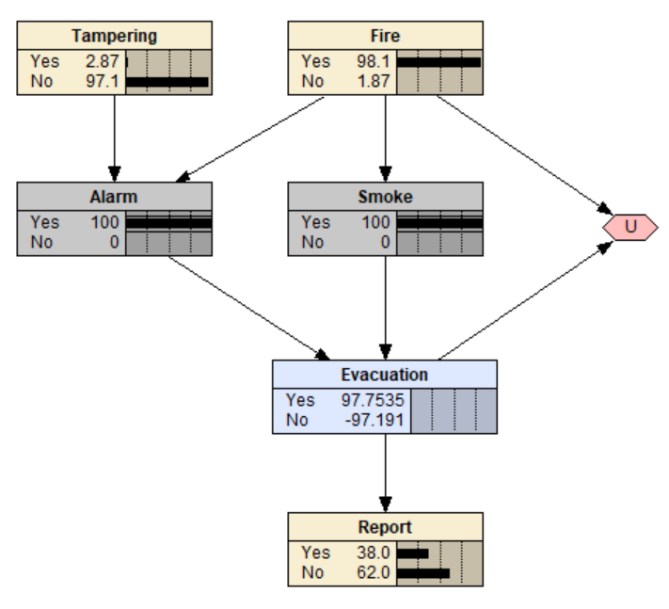

Question 2: Bayesian Networks, Netica
Q2.a. Design a BN using the nodes: Rain, LawnGrow, WaterRestrictions and Frost. Justify your design.

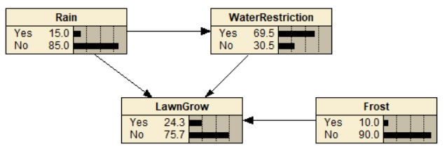

Justification:
The Network Structure designed in Netica is shown in the diagram above. The network models a causal relationship between the healthy growth of the lawn and external factors.

Rain serves as the Parent Node for Water Restrictions and Lawn Growth. The absence of rain increases the probability of the authorities enacting water restricting policies whilst reducing likelihood of a successful lawn growth. If water restrictions measures were to be implemented, it will further reduce the chances of regrowing the lawn by preventing the owner from watering the lawn.

Additionally, Frost has a small chance of occurring during winter is another factor that can adversely affect the healthy regrowth of the lawn. This Frost damage is independent of Rain and Water Restrictions, which is why it exists as a separate causal node affecting Lawn Growth.

The table below shows the justification for the networks design:
Item | Type | Justification
Rain | Chance Node | Represents the Chance of Raining
Water Restrictions | Chance Node | Represents the Chance of Water Restrictions
Lawn Grow | Chance Node | Represents the Chance for Law to Grow
Frost | Chance Node | Represents the Chance of Frost during Winter
Rain to Water Restrictions | Conditioning Link | Rain Reduces the likelihood of Water Restrictions
Rain to Lawn Grow | Conditioning Link | Rain Increases the chances of lawn growth
Water Restriction  to Lawn Grow | Conditioning Link | Water Restrictions take effect; it can reduce the chances of watering and regrowing the Lawn
Frost to Lawn Grow | Conditioning Link | Frost reduces the chances of lawn growth

Question 2: Bayesian Networks, Netica

Q2.b. Inspect your BN and report on any value assignments that will cause D-separation between any sets of nodes. Explain why this is the case in terms of Common Cause, Common Effect and Causal Chain.

Table below shows the d-separated nodes:

Statement | Rain ⊥ Frost
D-separated | True
Rule Applies | 1) Common Effect (Rain → Lawn Grow ← Frost)
Explanation | Lawn Grow is a Common Effect of Water Restrictions, Rain and Frost Due to this collider having a v-structure, it blocks information when Lawn Grow is unobserved, making Rain and Frost independent and d-separated.

Statement | Water Restrictions ⊥ Frost
D-separated | True
Rule Applies | 1) Common Effect (Water Restriction → Lawn Grow ← Frost)
Explanation | Lawn Grow is a Common Effect of Water Restrictions, Rain and Frost Due to this collider having a v-structure, it blocks information when Lawn Grow is unobserved, making Water Restriction and Frost independent and d-separated.

Statement | Rain ⊥ Frost | Water Restrictions
D-separated | True
Rule Applies | 1) Common Effect (Water Restrictions → Lawn Grow ← Frost)  2) Common Effect (Rain → Lawn Grow ← Frost)
Explanation | When Water Restrictions Node is Observed, Rain and Frost remains independent and d-separated because Lawn Grow is a Common Effect of and Frost.  This still blocks information when Lawn Grow is unobserved, making Rain and Frost independent and d-separated given Water Restrictions.

Question 2: Bayesian Networks, Netica

Q2.c. Quantify the relationships in the network by adding numbers for the CPTs. Justify the numbers in your CPTs

Rain Node
Yes | No | Justification
15 | 85 | Given that the area has been in drought for the past year, the probability of adequate rain for regrowing the lawn is low. A 15% probability of rain is assumed to allow for some possibility of rain to occur due to weather changes.

Frost Node
Yes | No | Justification
10 | 90 | The statement mentioned there is a small chance of Frost during winter, which has an adverse effect on the lawn growth by damaging lawn.

Water Restriction Node
Rain | Yes | No | Justification
Yes | 10 | 90 | When there is Rain, there is little chance of Water Restrictions being enacted; however, a small chance exists for unexpected events like the Water Distribution Plant due to technical issues
No | 80 | 20 | When there is No Rain for extended periods of time, it is very likely that Water Restrictions Measures may be put in place

Lawn Grow Node
Rain | Water Restrictions | Frost | Yes | No | Justification
Yes | Yes | Yes | 70 | 30 | Rain waters the lawn, regardless of water restrictions, but Frost might damage the lawn
Yes | Yes | No | 80 | 20 | Rain waters the lawn, regardless of water restrictions and no Frost means no damage
Yes | No | Yes | 75 | 25 | Rain waters the lawn but Frost would mean damage to the Lawn
Yes | No | No | 90 | 10 | Lawn has a high chance of growing healthy since there is Rain, No Water Restrictions and No Frost
No | Yes | Yes | 2 | 98 | No Rain combined with Water Restrictions and Frost results in the Lawn Not Growing
No | Yes | No | 10 | 90 | No Rain combined Water Restrictions means there is a slim chance of the lawn regrowing
No | No | Yes | 20 | 80 | No Rain and No Water Restrictions means the owner may still water the lawn, but Frost will still damage the lawn
No | No | No | 30 | 70 | No Rain and No Frost but having No Water Restrictions means the owner may still water lawn, increasing the likelihood of survival
Question 2: Bayesian Networks, Netica

Q2.d Using Netica, demonstrate the workings of your BN by determining the probability of the lawn growing in the following cases.

There is no evidence | 24.3 % of Growing Successfully
There is no rain and water restrictions have been applied | 9.20 % of Growing Successfully  In this scenario, No Rain and Water Restrictions were enacted, providing evidence to the Lawn Grow Node. The lawn has a slim 9.2% chance to grow successfully due to no rainfall and water restrictions preventing any watering.  In Question d.1), no nodes were observed, a more optimistic outlook that there was still a 15.0% chance of Rain occurring that year and a 69.5% chance of Water Restrictions being imposed, resulting in probability of Lawn Growing to be Successful is 24.3%.
There is Frost, but it has Rained | 74.5 % of Growing Successfully  Since it is Observed that it has Rained, there is also a much lower likelihood of water restrictions measures being taken. This increases the chances of the lawn growing successfully significantly. However, due to frost occurring over the winter, which has an adverse effect on Lawn Growth by damaging the lawn and reduces the probability of lawn growing successfully slightly.  Compared to Question d.1), the posterior probability for lawn growing successfully is much higher because it has Rained, with a success rate of 74.5%. This is much better than before since there was still the looming possibility of No Rain and Water Restrictions since no evidence was available to suggest rain was coming.

Question 3: D-separation (26 marks)
Q3.a. List the conditions under which you will be able to propagate evidence from Interest rate to Rent charged. That is, which nodes need to be instantiated or uninstantiated so that evidence can be propagated from Interest rate to Rent charged. Explain why this is the case using the terms Common Cause, Common Effect and Causal Chain where applicable.

Interest Rate to Rent Charged
Condition 1 | Housing Prices and Tenant Are Instantiated
Path | (Interest Rate → Housing Prices ← Property Location → Tenant ← Rent Charged)
Instantiated | Housing Prices, Tenant
Uninstantiated | Property Location, Interest Rate, Rent Charged, Desirable Investment
Explanation | When Housing Prices Node is Observed, it is a Common Effect of both Interest Rate and Property Location, this unblocks the v-structure and allows the information to propagate from Interest Rate to Tenant.  Moreover, the Tenant Node is a Common Effect of Property Location and Rent Charged, creating another v-structure. Observing Tenant will unblock the flow of information between Property Location and Rent Charge.  Ultimately, both Common Effect nodes (Housing Prices and Tenant) must be observed simultaneously, this unblocks the undirected path, allowing information to propagate between Interest Rate and Rent Charged. Therefore, making them conditionally dependent given Housing Prices and Tenant.
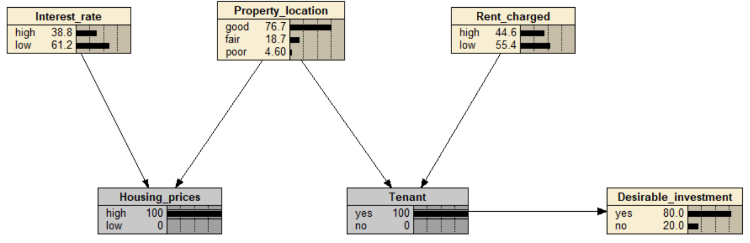

Question 3: D-separation (26 marks)

Q3.a.

Interest Rate to Rent Charged
Condition 2 | Housing Prices & Desirable Investment Instantiated
Path | (Interest Rate → Housing Prices ← Property Location → Tenant ← Rent Charged) (Tenant → Desirable Investment)
Instantiated | Housing Prices, Desirable Investment
Uninstantiated | Property Location, Interest Rate, Rent Charged, Tenant
Explanation | Similarly, observing Housing Prices, which is a common effect, unblocks the common effect structure and allows information to propagate from Interest Rate to Property Location.  The path contains Tenant, which is a Common Effect of Property Location and Rent Charged. Desirable Investment is connected to Tenant through a Causal Chain relationship.  Whilst Tenant itself is not directly observed, when Desirable Investment is observed, the collider at Tenant is unblocked. This allows Property Location to propagate information to Rent Charged and vice versa.  Ultimately, observing Desirable Investment and Housing Prices unblocks the path and allows information to pass between Interest Rate and Rent Charged, making them conditionally dependent given Housing Prices, Desirable Investment.
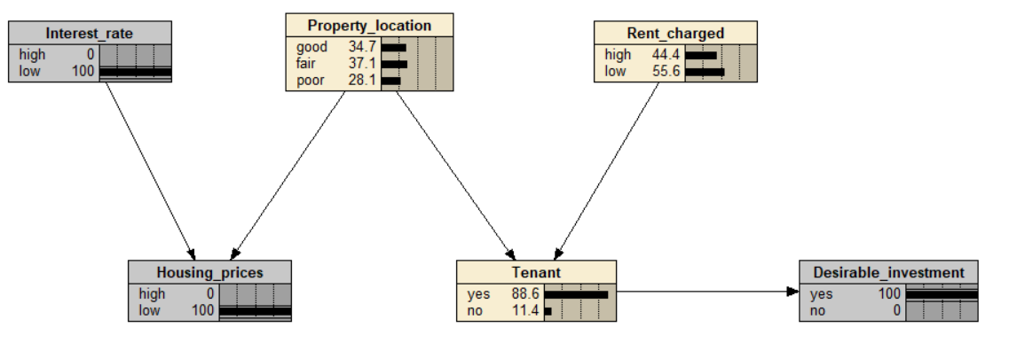

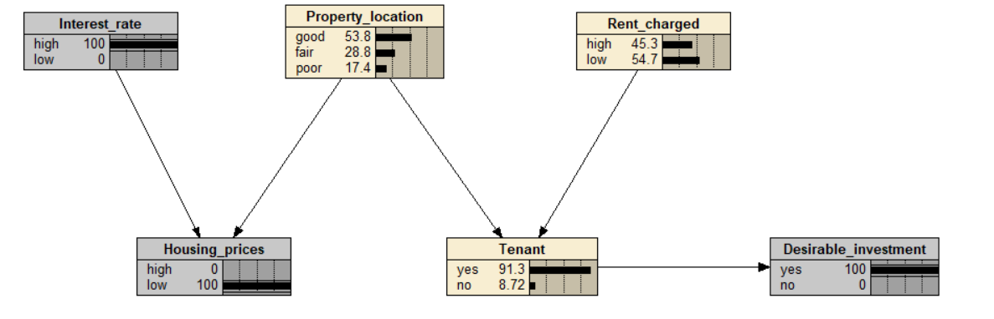

Question 3: D-separation (26 marks)

Q3.b. Repeat question (a) for propagating evidence from Desirable investment to Housing prices. Explain why this is the case using the terms Common Cause, Common Effect and Causal Chain where applicable.
Desirable Investment to Housing Prices
Condition 3 | No Node is Instantiated
Path | (Desirable Investment ← Tenant ← Property Location → Housing Prices)
Instantiated | None
Uninstantiated | Rent Charged, Property Location, Interest Rate, Housing Prices, Tenant, Desirable Investment
Explanation | No Nodes need to be Instantiated for Desirable Investment to Propagate Information up to the Housing Prices.  Desirable Investment has a direct conditional link to Tenant through a Causal Chain and information can freely flow between Tenant and Property Location via their Common Cause relationship.  Property Location is a Common Cause for Tenant and Housing Prices. When it is not observed, it allows information to flow freely and allows the information to propagate from Desirable Investment to Housing Prices.  This is the only undirected path between Desirable Investment and Housing Prices. Hence, both Desirable Investment and Housing Prices are dependent when no nodes are instantiated.
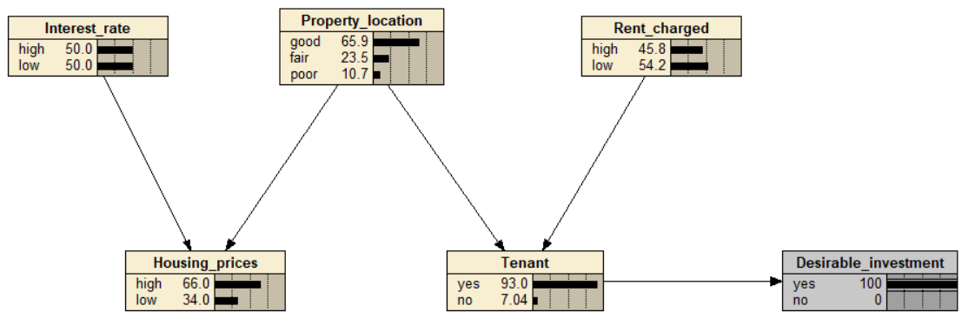

Question 3: D-separation (26 marks)

Q3.c. Repeat the above questions under the assumption that there is also an arc from Housing prices to Tenant (the corresponding BN, Q3c-BN-rental3.dne, is available on Moodle). Provide explanations using the terms Common Cause, Common Effect and Causal Chain where applicable.
Item (a)
Interest Rate to Rent Charged
Condition 1 | Tenant is Instantiated
Path | (Interest Rate → Housing Prices → Tenant ← Rent Charged)
Instantiated | Tenant
Uninstantiated | Property Location, Interest Rate, Rent Charged, Desirable Investment
Explanation | Unlike before, the new arc creates a Causal Chain relationship between Housing Prices and Tenant.  This change makes Tenant a Common Effect of three parent nodes, Property Location, Rent Charged, and Housing Prices. Tenant is a Common Effect of Housing Prices and Rent Charged. When Tenant is unobserved, it blocks information flow between these parent nodes.  When Tenant is observed, the v-structure becomes unblocked, and information can freely propagate from Interest Rate through Housing Prices to Rent Charged.  Unlike the original network, this new arc creates a simpler path where only one common effect structure that needs to be unblocked.  Ultimately, this results in Interest Rate and Rent Charged becoming conditionally dependent given Tenant.
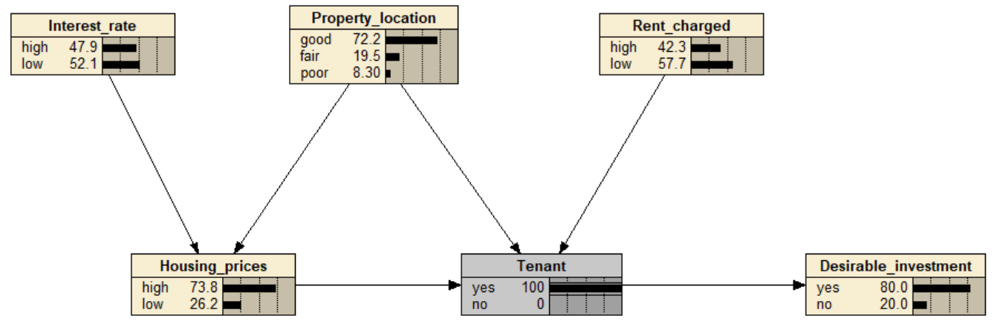

Question 3: D-separation (26 marks)

Q3.c.
Item (b)
Desirable Investment to Housing Prices
Condition 3 | No Node is Instantiated
Path | (Desirable Investment ← Tenant ← Housing Prices)
Instantiated | None
Uninstantiated | Rent Charged, Property Location, Interest Rate, Housing Prices, Tenant, Desirable Investment
Explanation | No Nodes need to be Instantiated for Desirable Investment to Propagate Information up to the Housing Prices.  Desirable Investments has a direct conditional link to Tenant through a Causal Chain.  The new conditional link, linking Housing Prices and Tenant creates a new Causal Chain Relationship, making a direct information flow from Desirable Investment through Tenant to Housing Prices.
